Market and Economic Update
  - March Quarter 2022

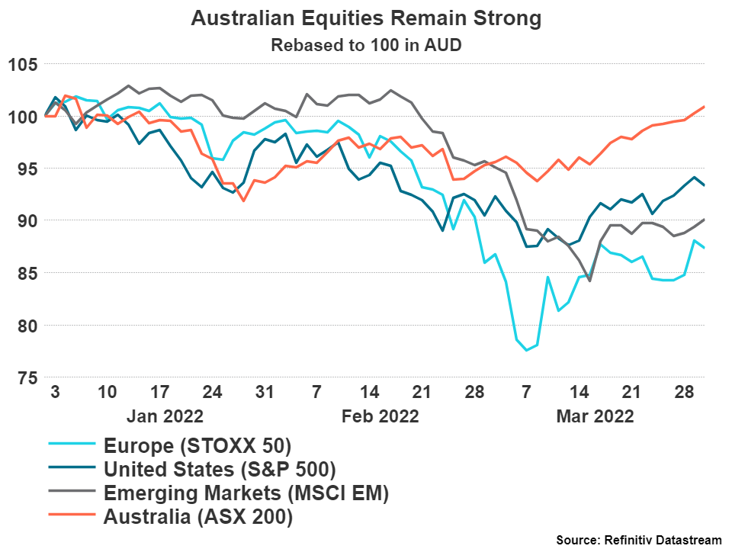
Markets in Review
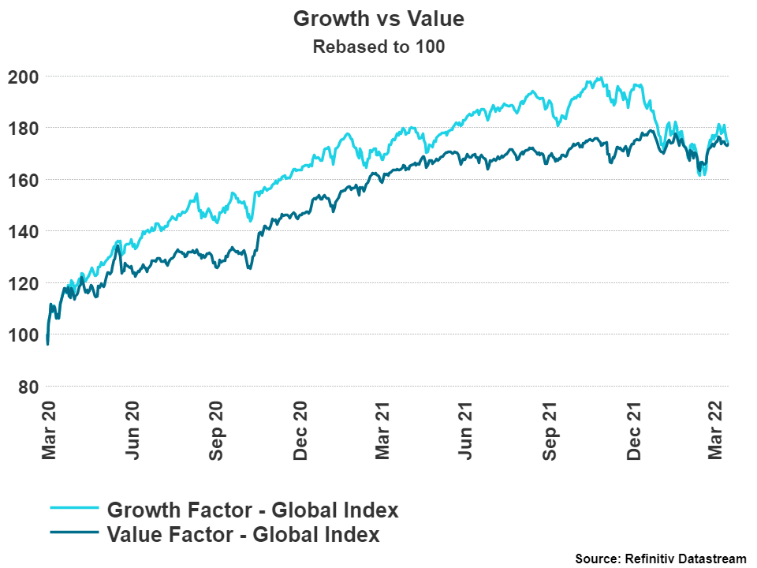
Positive news was difficult to come by in the first quarter of calendar year 2022. Interest rates, inflation and war were the main topics that culminated in a down quarter for Europe, The United States and Emerging Markets. This was the worst quarterly loss since the beginning of the pandemic for Europe and the US. Australia remained a safe haven trade due to relatively higher weights of materials, energy and financials companies in the market relative to other countries.
Australia returned 0.3% on the quarter, The United States fell 7.7%, Emerging Markets also fell 11.5%, whilst Europe was the worst performing market with a significant 17.4% drop.
Europe has been the most impacted equity market on the quarter due to the continued fallout from the war in Ukraine. Europe imports 60% of its energy from Russia and therefore remains the most at-risk region for disruptions amounting from this war.
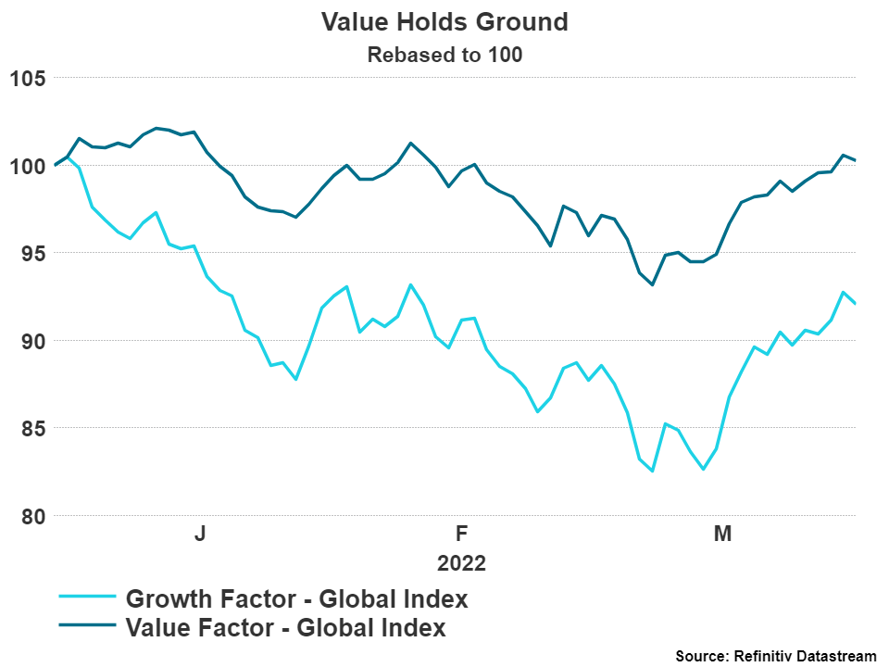
Value companies (companies with lower valuation ratios/mature companies) continued to outperform growth (companies with high valuation ratios/new companies with a strong growth runway/often don’t pay dividends or are yet to make profits).
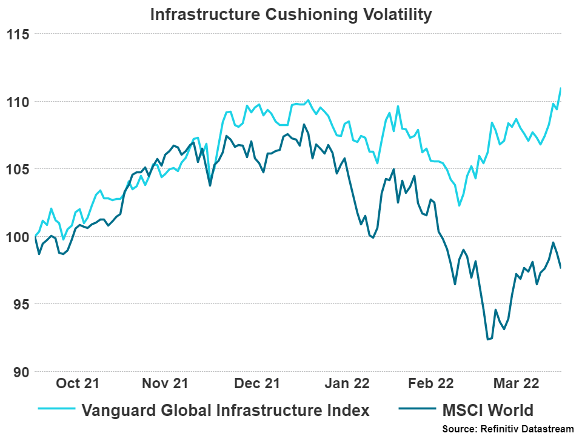
This is a distinct difference to the previous few years in which the economic environment has been conducive to growth outperformance as low rates, low inflation and low economic growth aided the growth of technology and healthcare. The overall performance since the market bottom of the early 2020 market crash is now equal between the two factors, as seen above.

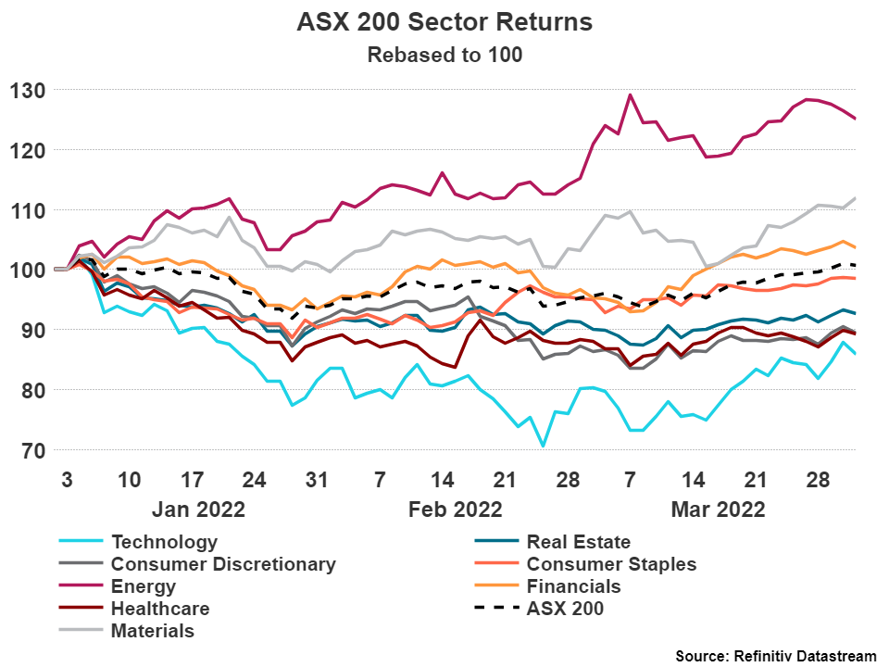
1.1 Australian Sector Returns
Significant divergence in sector returns continues to play out in this unique market environment. Sectors that have historically performed well during periods of elevated inflation and rising rates are showing their value with energy (20%), materials (9.4%) and financials (1.6%) being the best performing sectors across the quarter.
Consumer discretionary (-9.7%) was the worst performing sector on the quarter, closely followed by technology (-8.4%) and healthcare (-7.5%). These sectors performed well during the pandemic, however as the macroeconomic environment changes, they have struggled to continue this strong performance.

1.2 Infrastructure Returns
Infrastructure returns over the last six months have proved the ability for the asset class to protect capital during inflationary periods relative to the market. The ability for infrastructure assets to protect during inflationary periods is why it is necessary in portfolios, as it has different return characteristics to traditional equities.

Foreign Exchange Markets
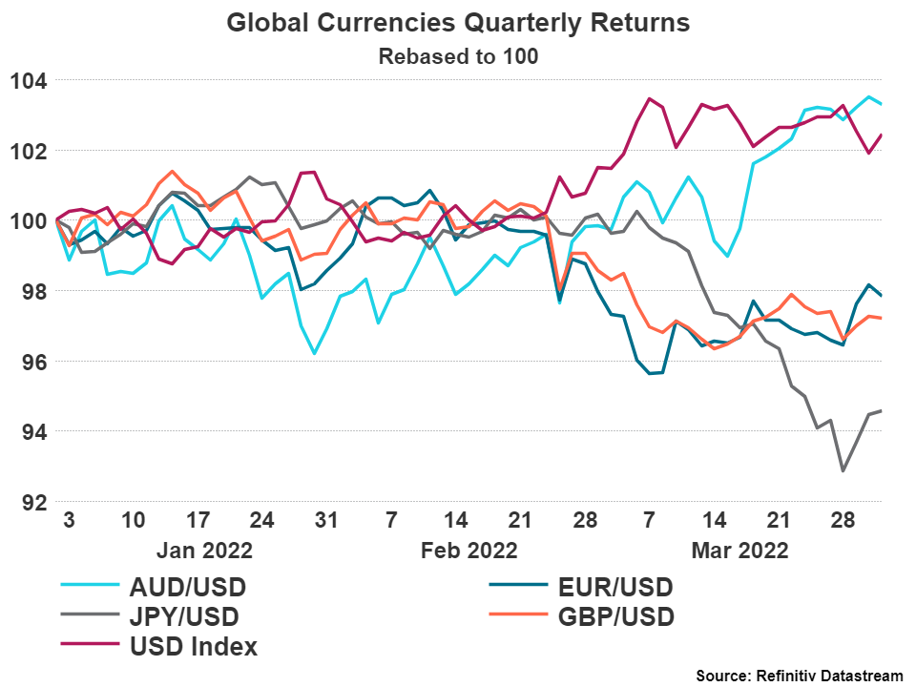
As indicated by the chart, currencies remained unchanged until the invasion by Russia into Ukraine. Immediately, it was obvious which currencies were perceived as safe havens. The US Dollar rose sharply following this event, finishing over 2.4% on the quarter. The Australian Dollar was the best performing currency during the quarter (3.3%) due to the same reasons that it was the best performing equity market, high weightings in the ASX 200 to sectors that perform well in this environment.
A surprising drop in the Japanese Yen, a currency generally seen as a safe haven currency, took place across the quarter as investors rotated money out of Yen into the US Dollar to take advantage of the higher interest rates that have been priced into the US market. The Bank of Japan have not indicated significant increases in interest rates, leaving the currency more exposed to inflationary pressures.

Fixed Income Markets
Using the iShares Global and Australian Bond Index products as proxies for the bond indexes, the losses to start the year are highlighted clearly in the chart on the next page. The global bond index fell 4.8% on the quarter, whilst the Australian index fell a deeper 5.9%.
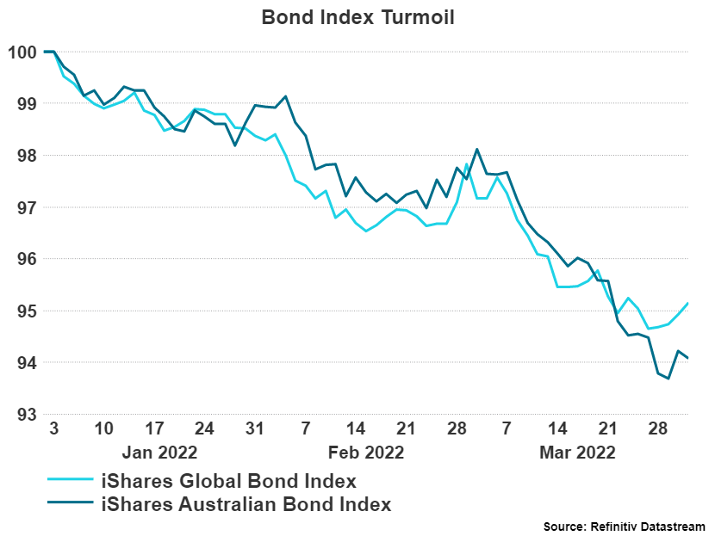
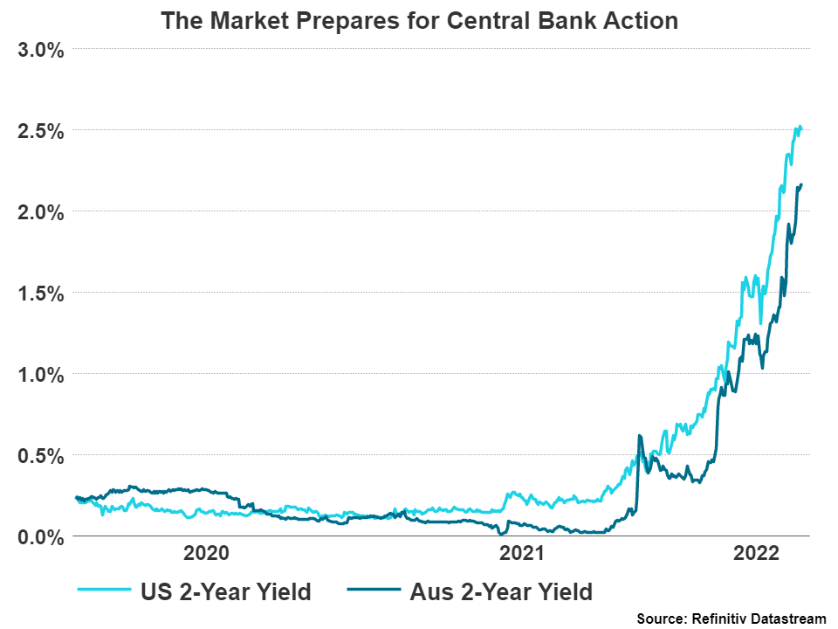
The beginning of 2022 has been one of the worst bond sell-off’s in history to start a year as yields continue to rise in the face of rising inflationary pressures that have stemmed from the global reopening and now the Russia-Ukraine War. China’s largest cities have also entered a severe lockdown due to rising coronavirus cases which may further exacerbate the global supply issues that have already been abundant.
Central banks continue to voice their concerns over rising inflationary costs and their willingness to fight this with higher interest rates. This has resulted in extremely sharp increases in short-term yields. This attitude change is extreme and is highlighted by the above chart. Central banks, prior to this inflationary outbreak had been conducting quantitative easing to suppress yields at rates next to 0%. Now the fixed income market has had to reprice in seven total rate increases in the US for 2022 and the increases that Australia will have to conduct. The Reserve Bank of Australia has not outlined specifically what this will look like as they await the inflation data to come through.

oUTLOOK
Increasingly hawkish central banks have continued to put pressure on equities, especially in the US as inflation has hit their economy the hardest thus far. We expect inflation to stay elevated over the short-term as the Russian-Ukraine War and lockdowns occurring in China will ensure pressures on supply chains continue. There were issues with supply chains before either of these events occurred, hence these are aggravating factors to the already existing problem.
In Australia, inflation has stayed somewhat subdued relative to the rest of the world. It is expected that this number will move upwards in the coming months as Australia is lagged but is not entirely isolated from the global economic trends.
The bottom line is that the focus of central bank policy has shifted to strictly rein in inflation. After being initially labelled “transitory”, inflation has remained elevated for a longer than expected period of time, in the United States especially. It is now expected that central bank interest rate increases will occur until the inflation rate falls back to the longer-term average. This may be at the expense of equity and bond holders in the short-term if central banks start to get very aggressive with this strategy and further increase interest rate expectations.
If inflation starts to moderate in the short-term, the need for aggressive interest rate policy will be somewhat subdued and will be positive for both bond and equity markets.
It appears that it all depends on what inflation is going to do next…

General Advice Warning
This update is issued by Ventura Investment Management Limited (AFSL 253045), which is a related body corporate of Centrepoint Alliance Limited.
The information provided is general advice only and does not take into account your financial circumstances, needs or objectives. Where you are considering the acquisition, or possible acquisition, of a particular financial product, you should obtain a Product Disclosure Statement for the relevant product before you make any decision to invest. Past performance does not necessarily indicate a financial product’s future performance. It is imperative that you seek advice from a registered professional financial adviser before making any investment decisions.
For more information, refer to the Financial Services Guide (FSG) for Ventura Investment Management Limited (available at).
Disclaimer
While Centrepoint Alliance Limited and its related bodies corporate try to ensure that the content of this update is accurate, adequate, and complete, it does not represent or warrant its accuracy, adequacy or completeness. Centrepoint Alliance Limited is not responsible for any loss suffered as a result of or in relation of the use of this update. To the extent permitted by law, Centrepoint Alliance Limited excludes any liability, including negligence, for any loss, including indirect or consequential damages arising from or in relation to the use of this update.

Refinitiv, 2022
Reuters, 2022
Refinitiv, 2022
Refinitiv, 2022
Refinitiv, 2022
Refinitiv, 2022
Refinitiv, 2022

